|  |  |
| --- | --- |
| **Project Case** |  |
| COMP6144  Web Programming |
| **Computer Science** | **O192-COMP6144-IV03-00** |
| ***Valid on*** *Odd Semester Year 2018/2019* | **Revision 00** |

1. Seluruh kelompok tidak diperkenankan untuk:

*The whole group is not allowed to:*

* + - Melihat sebagian atau seluruh proyek kelompok lain,

*Seeing a part or the whole project from other groups*

* + - Menyadur sebagian maupun seluruh proyek dari buku,

*Adapted a part or the whole project from the book*

* + - Mendownload sebagian maupun seluruh proyek dari internet,

*Downloading a part or the whole project from the internet,*

* + - Mengerjakan soal yang tidak sesuai dengan tema yang ada di soal proyek,

*Working with another theme which is not in accordance with the existing theme in the matter of the project,*

* + - Melakukan tindakan kecurangan lainnya,

*Committing other dishonest actions,*

* + - Secara sengaja maupun tidak sengaja melakukan segala tindakan kelalaian yang menyebabkan hasil karyanya berhasil dicontek oleh orang lain / kelompok lain.

*Accidentally or intentionally conduct any failure action that cause the results of the project was copied by someone else / other groups.*

1. Jika kelompok terbukti melakukan tindakan seperti yang dijelaskan butir 1 di atas, maka **nilai kelompok** yang melakukan kecurangan (menyontek maupun dicontek) akan di – **NOL** – kan.

*If the group is proved to the actions described in point 1 above, the score of the group which committed dishonest acts (cheating or being cheated) will be “Zero”*

1. Perhatikan jadwal pengumpulan proyek, segala jenis pengumpulan proyek di luar jadwal tidak dilayani.

*Pay attention to the submission schedule for the project, all kinds of submission outside the project schedule will not be accepted*

1. Jangan lupa untuk melihat kriteria penilaian proyek yang ditempel di papan pengumuman, atau tanya asisten anda.

*Don’t forget to look at the project assessment criteria that posted on the announcement board, or ask your teaching assistant.*

1. Persentase penilaiaan untuk matakuliah ini adalah sebagai berikut:

*Marking percentage for this subject is described as follows:*

|  |  |  |
| --- | --- | --- |
| **Tugas Mandiri**  *Assignment* | **Proyek**  *Project* | **UAP**  *Final Exam* |
| - | 100% | - |

1. Software yang digunakan pada matakuliah ini adalah sebagai berikut:

*Software will be used in this subject are described as follows:*

|  |
| --- |
| **Software**  *Software* |
| PHP Composer  PHP Storm 2017.1  XAMPP 3.22 (PHP >= 7, MySQL)  IE / Firefox / Chrome |

## Ekstensi file yang harus disertakan dalam pengumpulan tugas mandiri dan proyek untuk matakuliah ini adalah sebagai berikut:

*File extensions should be included in assignment and project collection for this subject are described as follows:*

|  |  |
| --- | --- |
| **Tugas Mandiri**  *Assignment* | **Proyek**  *Project* |
| - | Folder Project (PHP, SQL, image files (JPG/PNG/GIF), CSS, ENV, JSON, LOCK, XML, JS, CSS, SCSS, VUE, HTACCESS, TXT, ICO, CONFIG, ARTISAN, MD) |

## Soal

*Case*

General Provisions:

* Use **MySQL** asdatabase and must using **Laravel Migration** features.
* **All file upload** feature such as image and document must be **stored to server storage**.
* Use PHP Framework **Laravel 5.5** to build the project.
* Use Laravel **MVC** concept (**Model, View, Controller**) to build the project.
* Use **Eloquent Query / Query Builder** to work with database.
* You are free to design your own database table **based on the given requirements**.
* Print screen given below is only an example. You are free to create your own user interfaces.
* It is **prohibited** to install any kind of Laravel packages. You must use fresh installation of **Laravel 5.5**.
* Only **validation** in the **backend** (using Laravel) will be marked.

**dIV Forum**

**dIV** is famous announcer company in Indonesia. To have a better engagement with their customers, **dIV** company wants to create a website for their **Forum**. In that website, people can find any information that discussed among community.

As a web developer, you are asked to create a website using **Laravel 5.5** for this forum. There are threetypes of user’s role in this website: **Admin**, **Member**, and **Guest** (**non-logged-in user**). For each role, the website must contain at least these pages:

* + - Admin
* Home
* Forum’s Thread
* Profile
* Inbox
* My Forum
* Master User
* Master Forum
* Master Category
  + - Member
* Home
* Forum’s Thread
* Profile
* Inbox
* My Forum
  + - Guest
* Login
* Register
* Home

Each page shows **greeting to user** and **current date time**. The descriptions for each page are:

1. Login

This page allows user to log in to the website. This page is accessible only for **Guest**. Display an **error message** on the login page if user enters the wrong combination of **Email** and **Password**.

If user has entered correct **Email** and **Password combination**, the page will be redirected to the **Home Page for Member** or **Admin** based on the user’s role and if user **checks** the “**Remember Me**” **checkbox**, the website will save the **Email** and **Password** using **cookies**.

After the user successfully **logged in** to the website, provide a **Logout** menu to **log the user out** from the website.

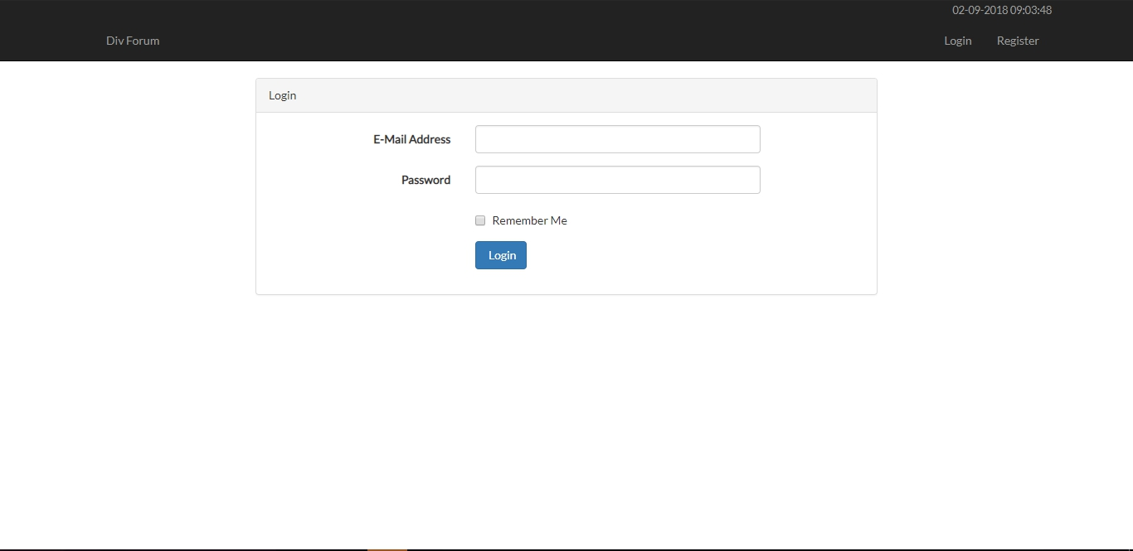

Figure 1. Login Page

1. Register

This page allows guests to **register** themselves as a **dIV Forum** **Member**. Validate this page is accessible only for **Guest**. Display an **error message** if user input incorrect personal data. The following table shows the existing fields on this page and the validation for each field:

|  |  |
| --- | --- |
| **Field** | **Information** |
| **Name** | **Must be filled** with **maximum 255 characters length** |
| **Email** | **Must be filled** with **valid email format** and **unique** |
| **Password** | **Must be filled** with **minimum 6 characters length** |
| **Confirm Password** | **Must be filled** and **same with password** |
| **Phone** | **Must be filled** with **numbers only** |
| **Gender** | **Must be selected** |
| **Address** | **Must be filled** and **ends with** ‘**Street**’ |
| **Profile Picture** | **Must be selected** and must match one of the **allowed MIME types (jpeg, png, jpg)** |
| **Birthday** | **Must be filled** with **date format**  Must be **older than 12 years old** |
| **Agreement** | **Must be selected** |

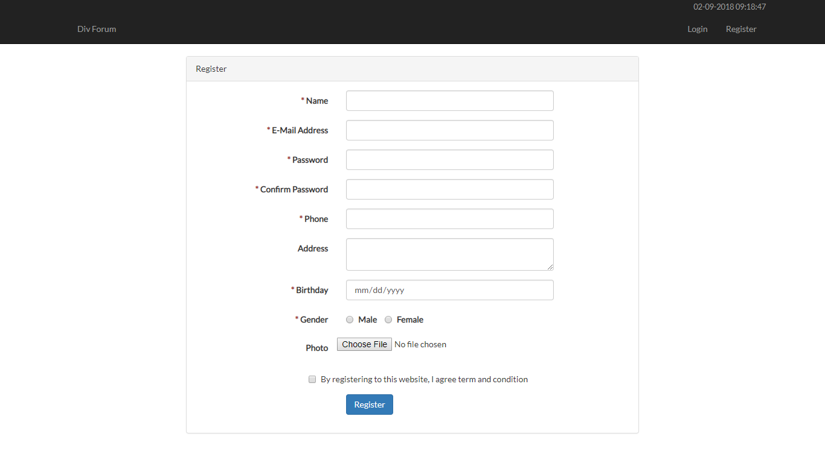

Figure 2. Register Page

1. Home

This page allows user to **see** all **dIV Forum** discussion. This page allows user to **search forum by title**, and **category name**. This page is accessible for **all users**. Forum discussion is displayed using **pagination** with **5** forums for each page. If user **selects** the forum, then the user will be redirected to **Forum’s Thread Page**.

In this page, there is an **Add Forum** button. Validate the button only visible if the **user** has **logged in**. If user clicks **Add Forum** button, then the user will be redirected to **Add Forum Page**.

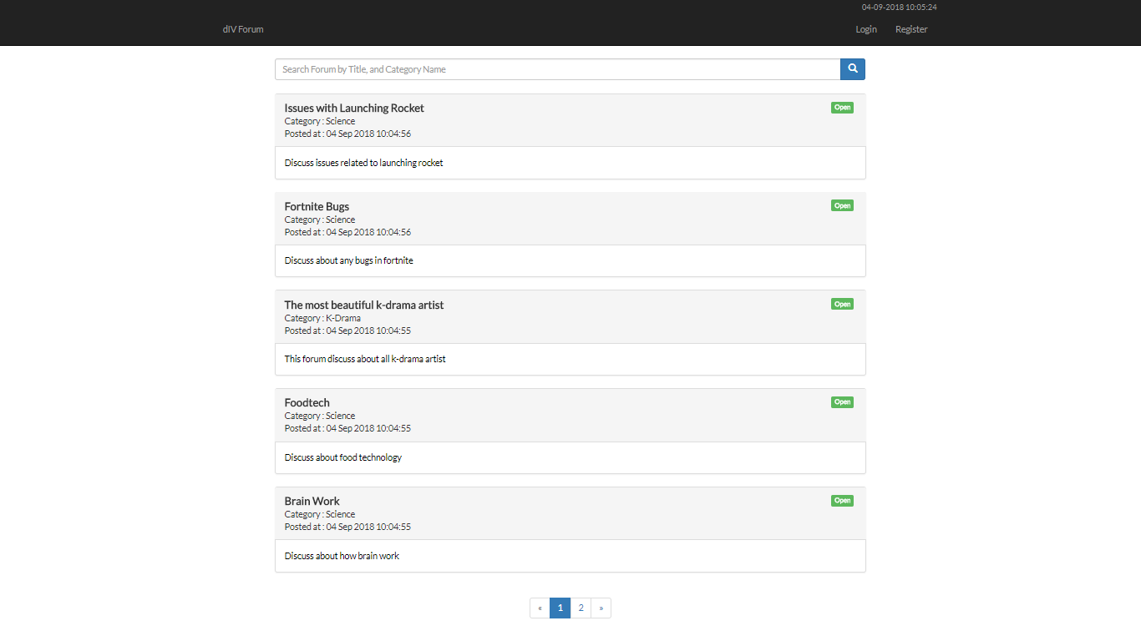

Figure 3. Home Page (for Guest)

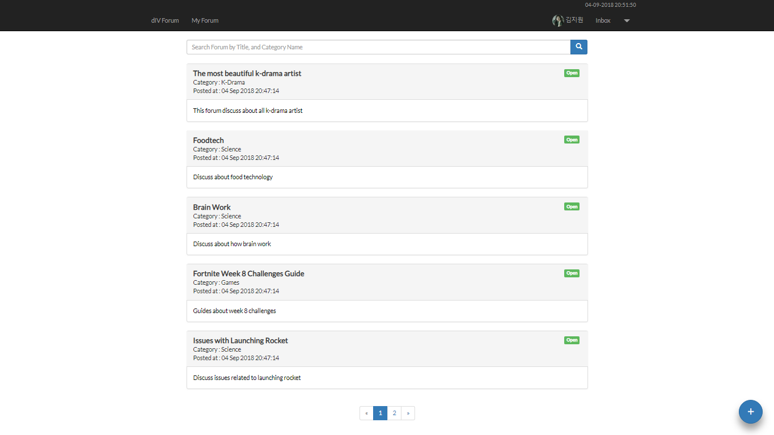

Figure 4. Home Page (for Member and Admin)

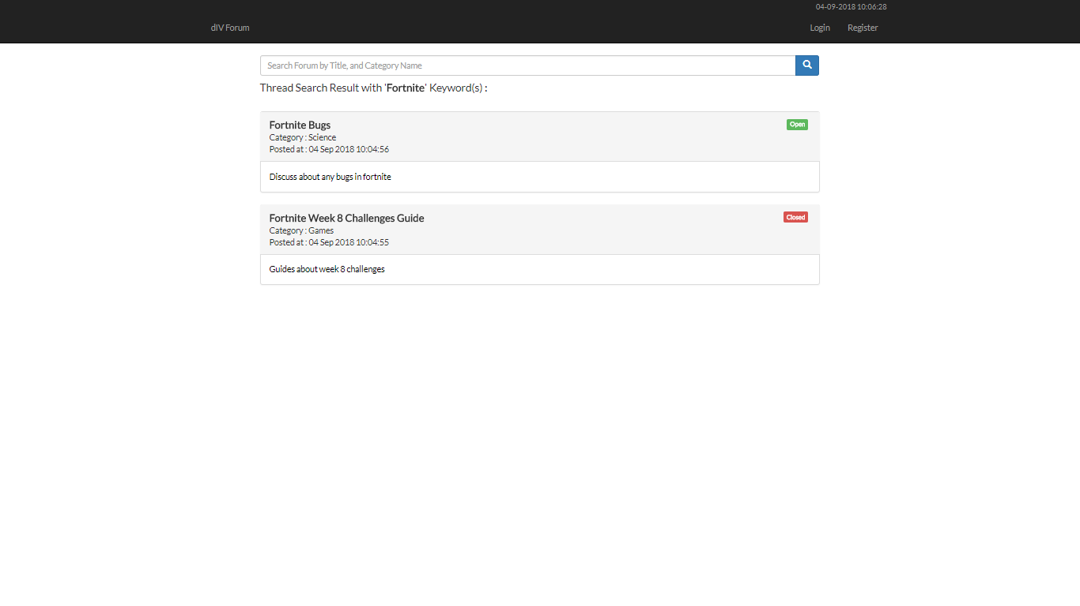

Figure 5. Searching Forum with 'Fortnite' Keyword

1. Add Forum Page

This page is accessible for **Member** and **Admin**. This page allows user to **insert** new forum. Display an **error message** if user input incorrect data. The following table shows existing fields in the **Add Forum Page** and the validation for each field:

|  |  |
| --- | --- |
| **Field** | **Information** |
| **Name** | **Must be filled** |
| **Category** | Must be **selected** |
| **Description** | Optional |

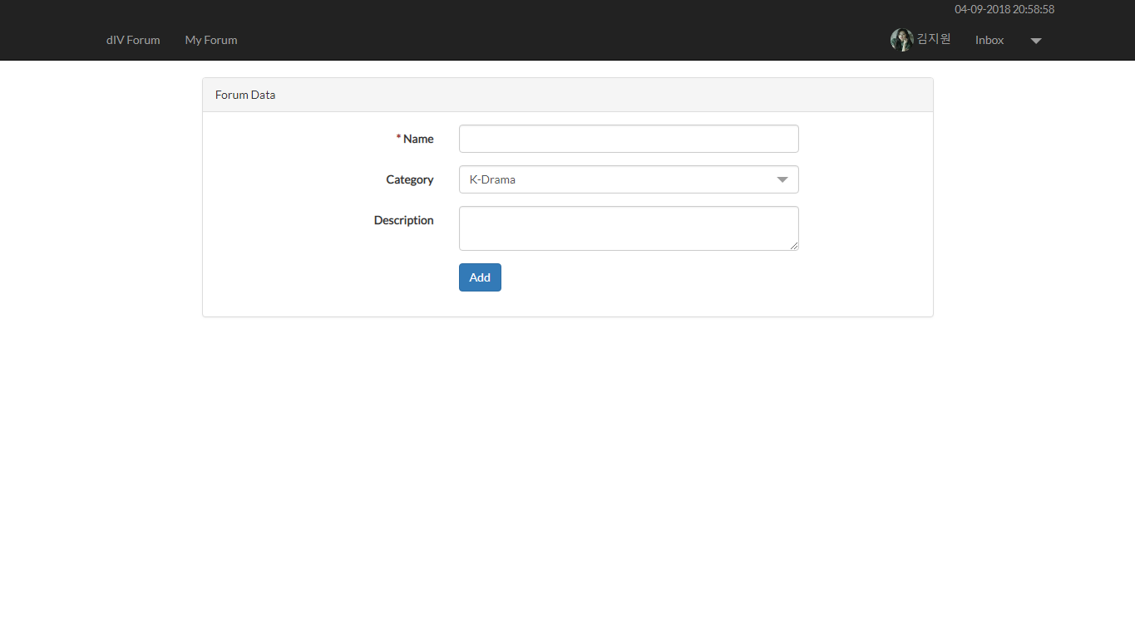

Figure 6. Add Forum Page

1. Update Forum Page

This page is accessible to **Member** and **Admin**. This page allows user to **update** their ownforum. Display an **error message** if user input incorrect data. The following table shows existing fields in the **Update Forum Page** and the validation for each field:

|  |  |
| --- | --- |
| **Field** | **Information** |
| **Name** | **Must be filled** |
| **Category** | **Must** **be** **selected** |
| **Description** | **Optional** |

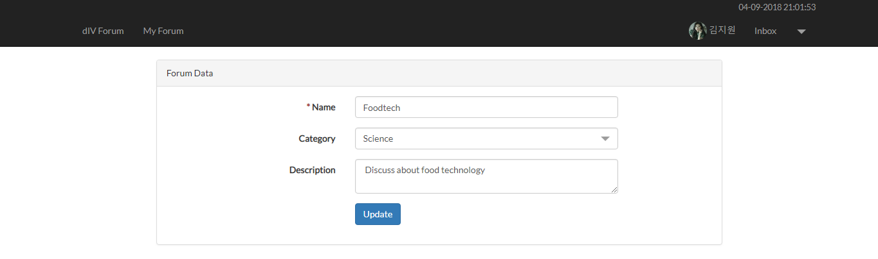

Figure 7. Update Forum Page

1. Forum’s Thread Page

This page is accessible for all users. This page allows user to **view** the threads for selected forum and search the threads by **thread content** or **thread owner name**. Display forum information such as **forum title**, **forum content**, **forum status** (**open** or **closed**), **forum owner**, **forum creation date**, **thread content**, **thread** **owner**, **thread** **owner**’**s** **role**, and **thread creation** **date**. All threads are **displayed** using **pagination** with **5** threadsfor each page. If there are **no threads** in selected forum, just show “**This forum doesn’t have any thread**”. Make sure all **thread**’**s owner name** can be **navigated** by clicking to redirect user to **profile page**.

The user can also **post** a thread to current forum by using the form below the thread. The form can only appear to **Member** and **Admin**, and if the forum **status** is **open**. The requirements for each field are:

|  |  |
| --- | --- |
| **Field** | **Information** |
| **Content** | **Must be filled** |

The user can also **update** or **remove** their **own thread**. Validate that the **update** and **delete** buttons only appeared to **the current logged in user**’**s thread**. If the **user** clicked the **update** **button**, redirect user to **Update Thread** **Page**. If user clicked the **delete** button, then **delete** the selected thread.

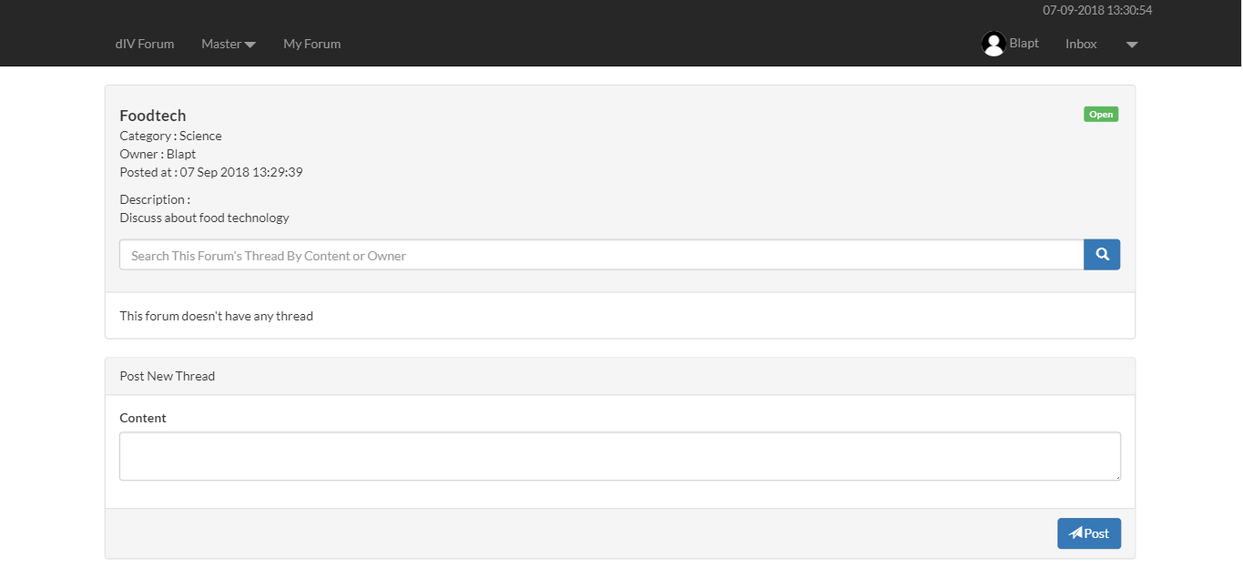

Figure 8. Forum's Thread Page (No Thread)

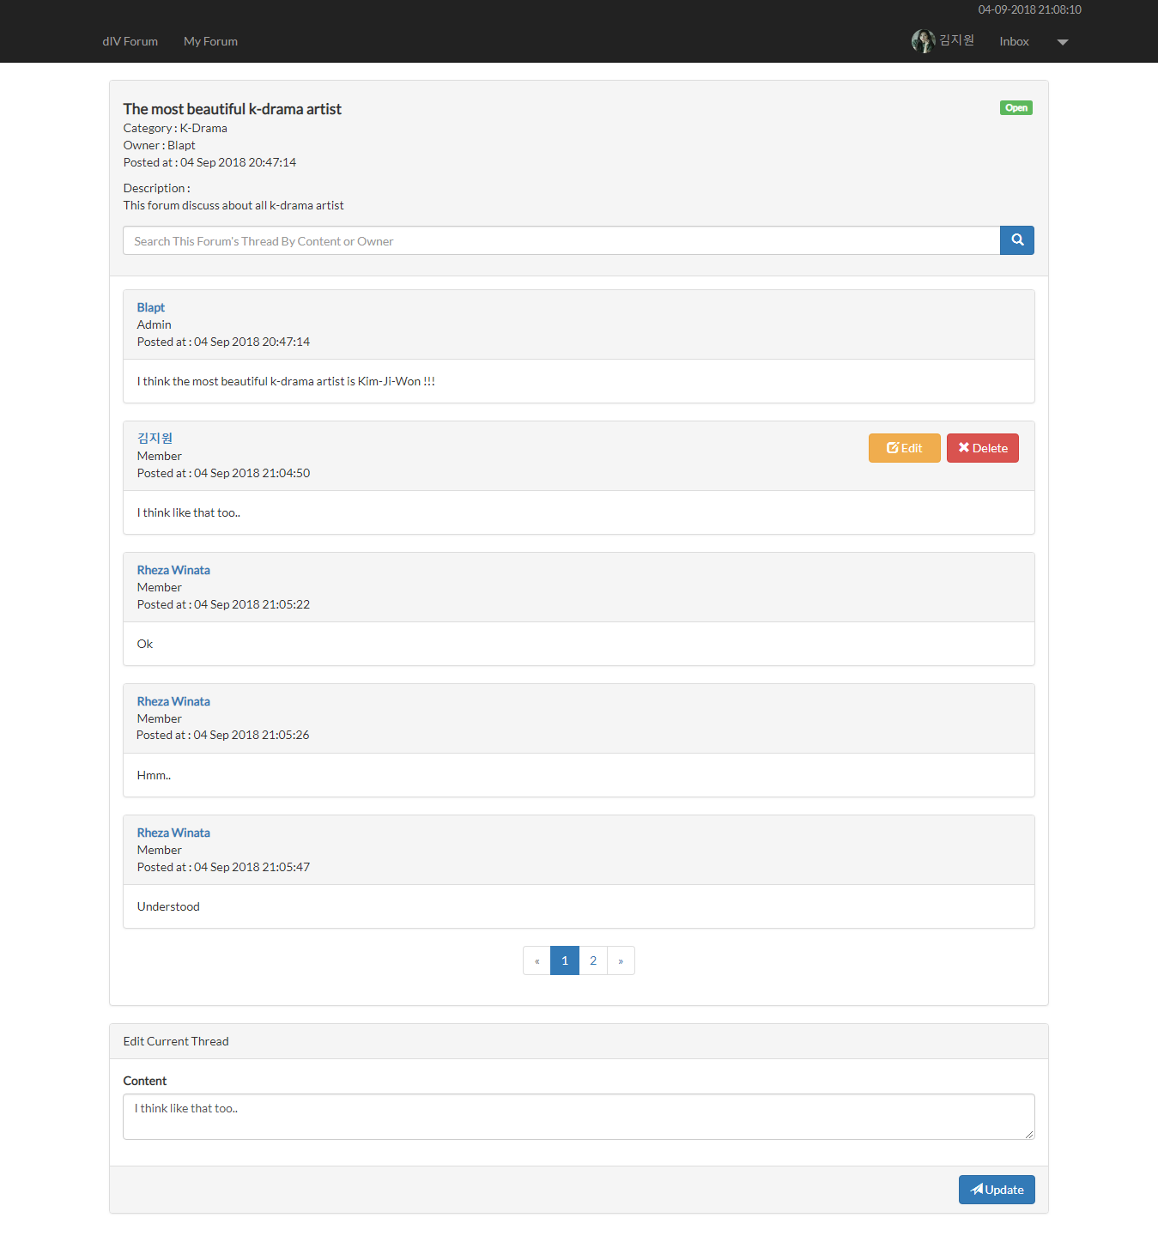

Figure 9. Forum's Thread (With Thread)

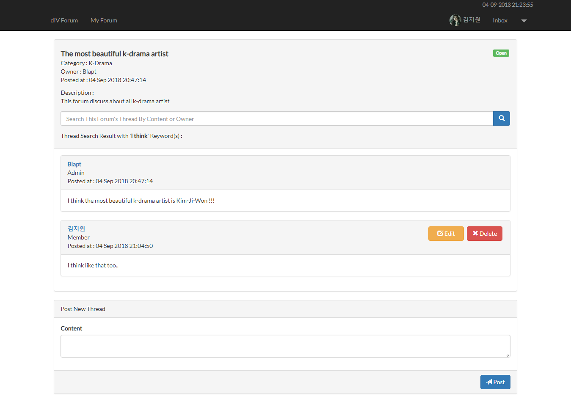

Figure 10. Forum's Thread Page (Search with Keyword 'I think')

1. Update Thread Page

This page allows user to **update** their thread content. This page is accessible only to **Member** or **Admin**. The **requirements** for each field are:

|  |  |
| --- | --- |
| **Field** | **Information** |
| **Content** | **Must be filled** |

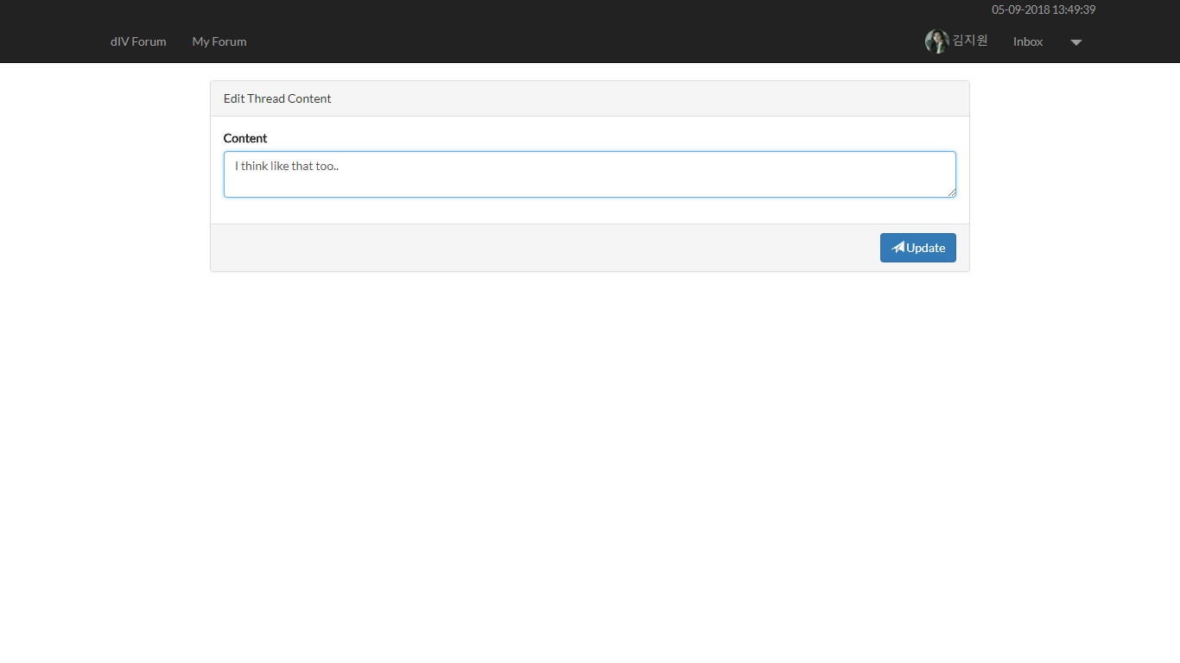

Figure 11. Update Thread Page

1. Profile Page

This page is accessible to **Member** or **Admin**. This page allows user to **see their profile** or **another** **user**’**s** **profile**.

There are some requirements on this page:

* If the user is viewing their own profile, validate that only **Edit** button is **visible**. If the **Edit** button is clicked, then redirect user to **Edit Profile** page.
* If the user is viewing other user’s profile, validate that the **Send Message** form and **Vote** form are **visible**. If the **Send Message** button is **clicked**, validate that the **message** field **must be filled** beforehand and then send the **corresponding message** to the user. For the **vote** button, there are 2 kinds of buttons that is **Good Vote** button or **Bad Vote** button, if the **Good Vote** button is clicked, then increase the user’s **good popularity** and if the **Bad Vote** button is clicked, then increase the user’s **bad popularity**.

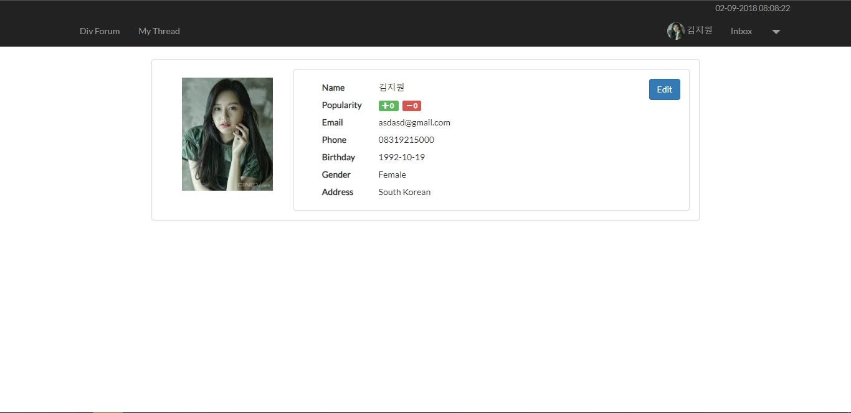

Figure 12. Profile Page (Opening Current Logged In User)

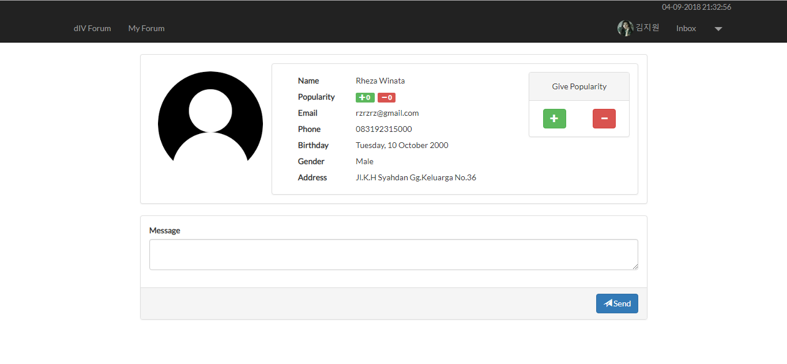

Figure 13. Profile Page (Viewing Another User Profile)

1. Inbox Page

This page allows user to **view** and **delete** messages they received. Display message information such as **message content**, **message sender**, and **message creation date**. Validate that this page only accessible for **Member** and **Admin**. In this page, all messages displayed using **pagination** with **10** messageseach page. If user click **Delete button**, then **delete** the message.

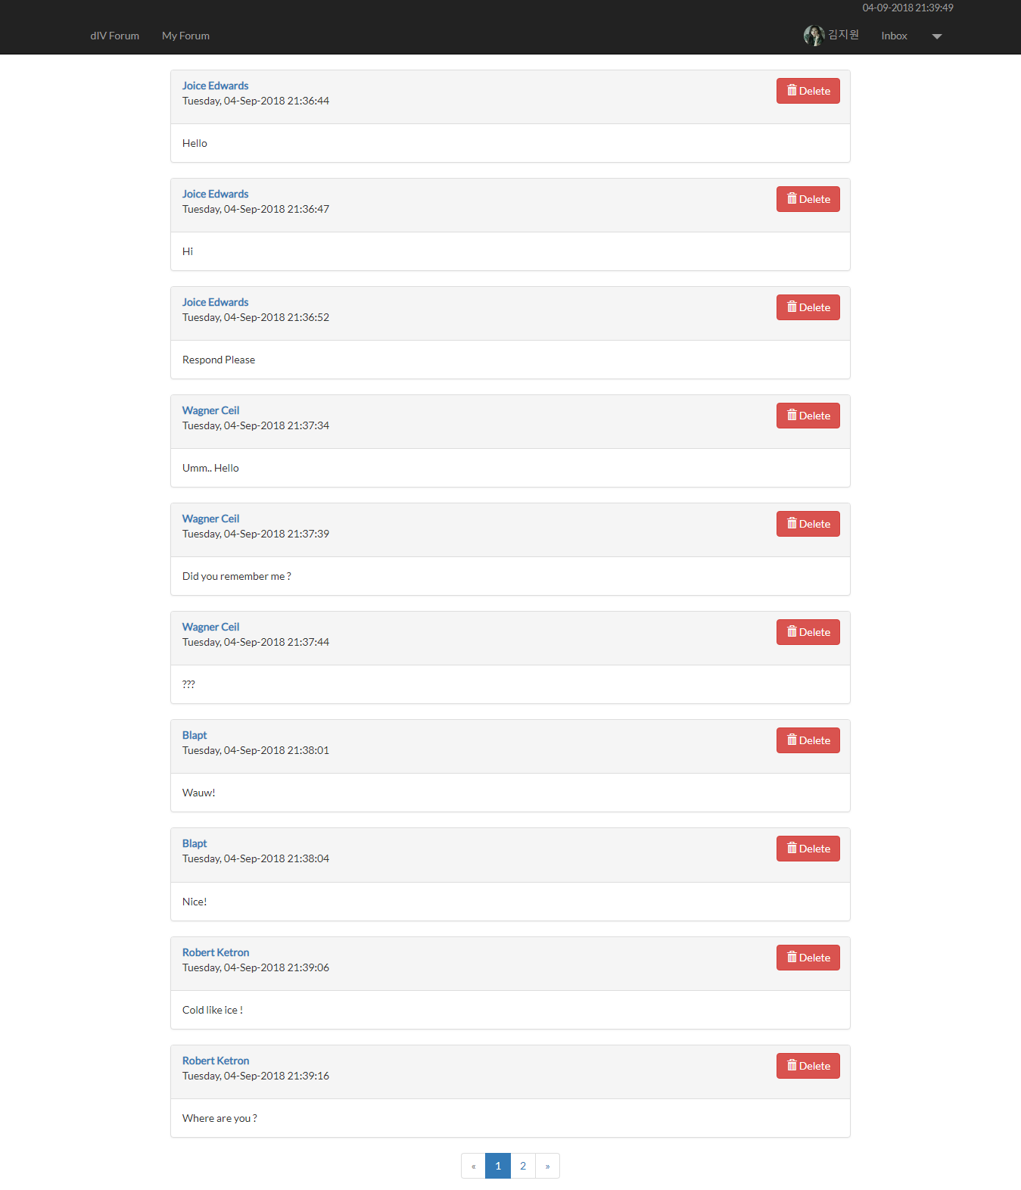

Figure 14. Inbox Page

1. My Forum Page

This page is accessible by clicking **My Forum** navigation menu. Validate this page only accessible to **Member** and **Admin**. This page **shows** all **forum** that user has posted by using **pagination** with **5** forums per page and allows user to **edit** or **close** that forum.Display forum information such as **forum title**, **forum status** and **forum content**.

Each forum in the lists have ‘**Edit**’ and ‘**Delete**’ buttons:

* If the user **clicks** **Edit** button, then redirect user to **Update Forum Page**.
* If the user **clicks** **Close** **button**, then change the **selected** forum **status** to ‘**Closed**’. The **Close and Edit button** are **visible** if the **forum** **status** is not ‘**Closed’**.

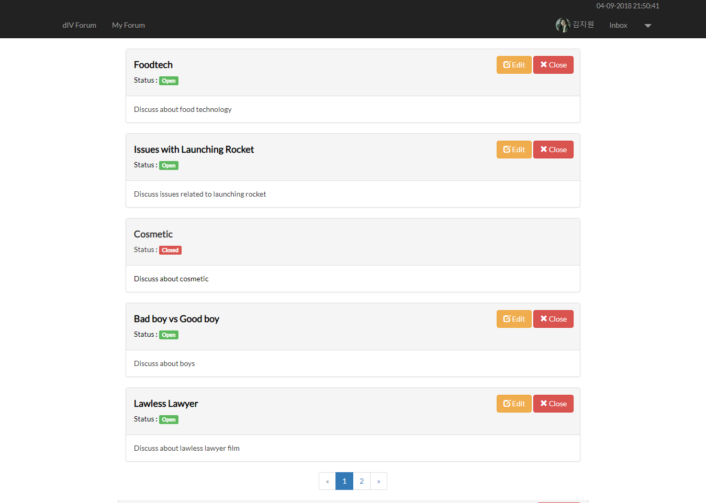

Figure 15. My Forum Page

1. Master User Page

This page shows all users using **pagination** with **5** users each page. This page is only accessible to **Admin**.

In this page, there are ‘**Add New User**’button, ‘**Edit**’ button and ‘**Delete**’ button:

* If user click **Add New User** button, then redirect user to **Add User Page**.
* If user click **Edit** button, then redirect user to **Update User Page**.
* If user click **Delete** button, then **delete** theuser.

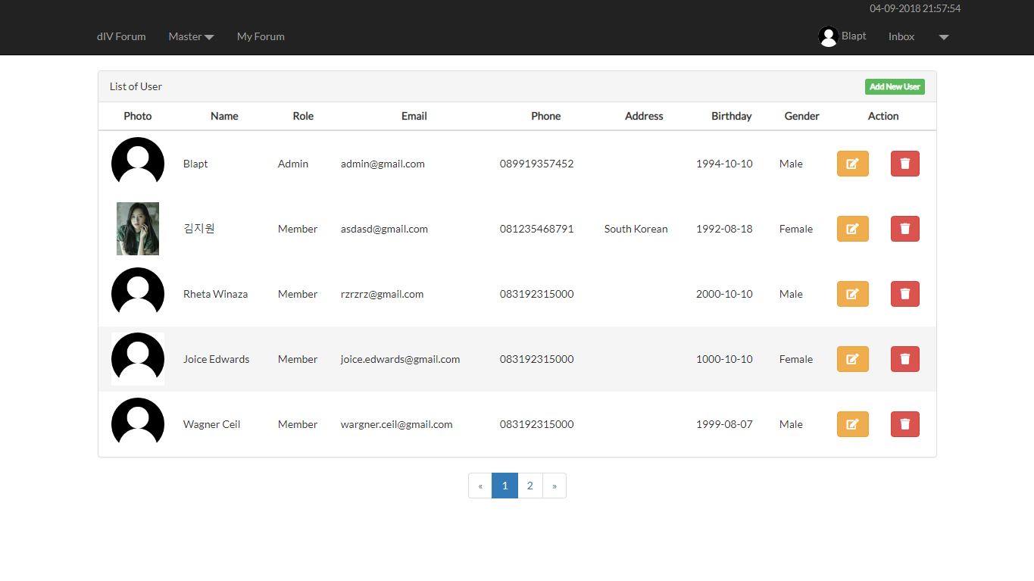

Figure 16. Master User Page

1. Add User Page

This page allows **Admin** to **add new user**. Display an **error message** if the input is incorrect. The following table shows existing fields in the **Add User Page** and the validation for each field:

|  |  |
| --- | --- |
| **Field** | **Information** |
| **Name** | **Must be filled** with **maximum 255 characters length** |
| **Role** | **Must be selected** |
| **Email** | **Must be filled** with **email validation** and **unique** |
| **Password** | **Must be filled** with **minimum 6 characters length** |
| **Confirm Password** | **Must be filled** and **same with password** |
| **Phone** | **Must be filled** and in **integer** **format** |
| **Gender** | **Must be selected** |
| **Address** | **Must be filled** and **ends with** ‘**Street**’ |
| **Profile Picture** | **Must be selected** and must match one of the **allowed MIME types (jpeg, png, jpg)** |
| **Birthday** | * **Must be filled** with **date format** * **Must** **be** **older than 12 years old** |

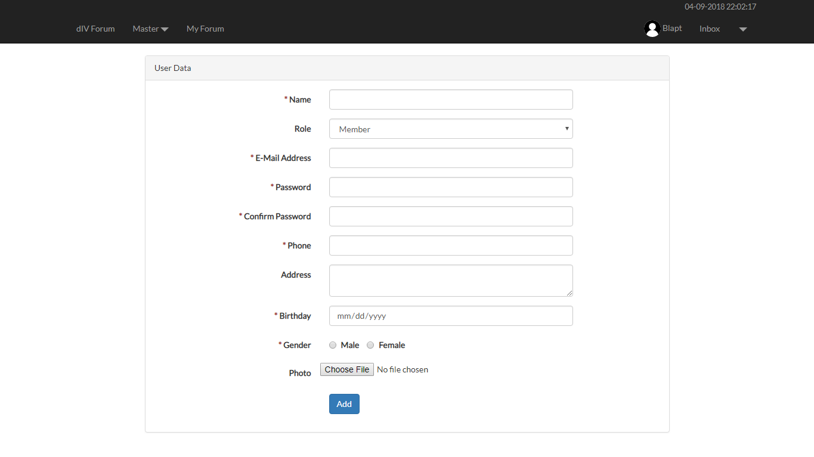

Figure 17. Add User Page

1. Edit Profile Page

This page allows user to **update** their data. Display an **error message** if user input incorrect data. The following table shows existing fields in the **Edit Profile Page** and the validation for each field:

|  |  |
| --- | --- |
| **Field** | **Information** |
| **Name** | **Must be filled** with **maximum 255 characters length** |
| **Email** | **Must be filled** with **email validation** and **unique** |
| **Password** | **Must be filled** with **minimum 6 characters length** |
| **Confirm Password** | **Must be filled** and **same with password** |
| **Phone** | **Must be filled** and in **integer** **format** |
| **Gender** | **Must be selected** |
| **Address** | **Must be filled** and **ends with** ‘**Street**’ |
| **Profile Picture** | **Must be selected** and must match one of the **allowed MIME types (jpeg, png, jpg)** |
| **Birthday** | * **Must be filled** with **date format** * **Must be** **older than 12 years old** |

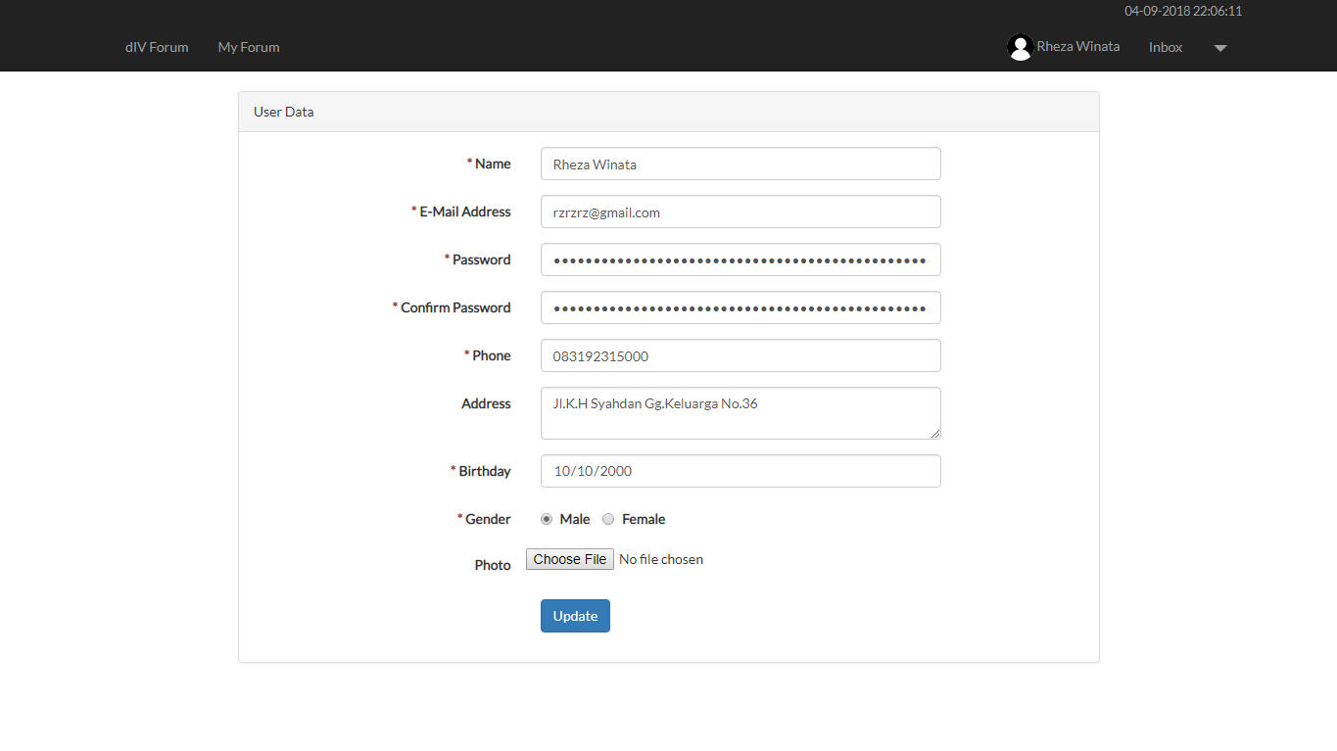

Figure 18. Edit Profile Page

1. Update User Page

This page allows **Admin** to **update** user data. Display an **error message** if user input incorrect data. The following table shows existing fields in the **Edit Profile Page** and the validation for each field:

|  |  |
| --- | --- |
| **Field** | **Information** |
| **Name** | **Must be filled** with **maximum 255 characters length** |
| **Role** | **Must be selected** |
| **Email** | **Must be filled** with **email validation** and **unique** |
| **Password** | **Must be filled** with **minimum 6 characters length** |
| **Confirm Password** | **Must be filled** and **same with password** |
| **Phone** | **Must be filled** and in **integer** **format** |
| **Gender** | **Must be selected** |
| **Address** | **Must be filled** and **ends with** ‘**Street**’ |
| **Profile Picture** | **Must be selected** and must match one of the **allowed MIME types (jpeg, png, jpg)** |
| **Birthday** | * **Must be filled** with **date format** * **Must be** **older than 12 years old** |

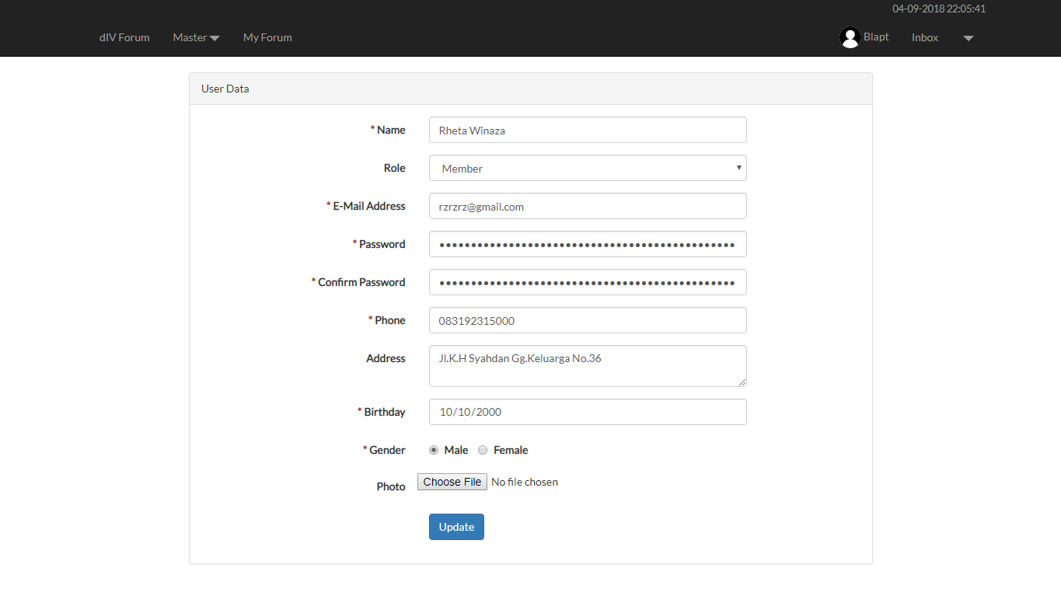

Figure 19. Update User Page

1. Master Forum Page

This page shows all forums using **pagination** with **10** forums each page. This page is accessible only for **Admin**.

In this page, there are ‘**Delete**’ button and ‘**Close**’button:

* If the user clicks **Close** **button**, then **update** selected forum **status** to ‘**Closed**’. Validate **Close button** only **enabled** for forum that the **status** still ‘**Open**’.
* If the user clicks **Delete** **button**, then **delete** the forum.

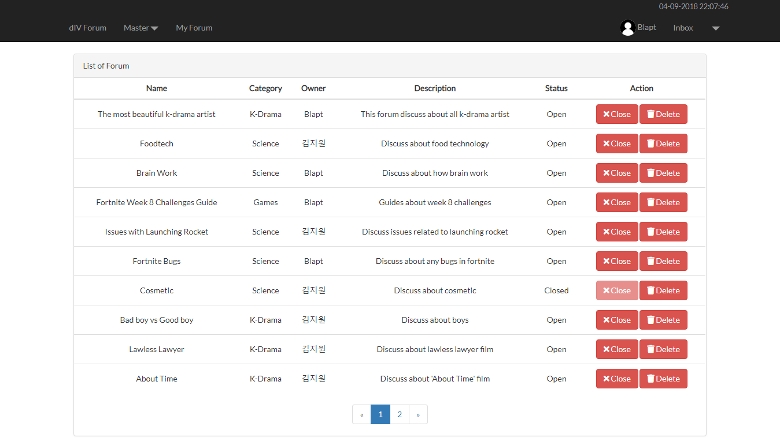

Figure 20. Master Forum Page

1. Master Category Page

This page allows **Admin** to manage all categories. In this page, there are ‘**Add**’ button, ‘**Edit**’ button, and ‘**Delete**’ button:

* If the user clicks **Add button**, validate **name field** must be **filled** before user can **add** the category. Display an error message if user input incorrect data.
* If the user clicks **Edit** **button**, then redirect user to **Edit Category Page**.
* If the user clicks **Delete** **button**, then **delete** the category.

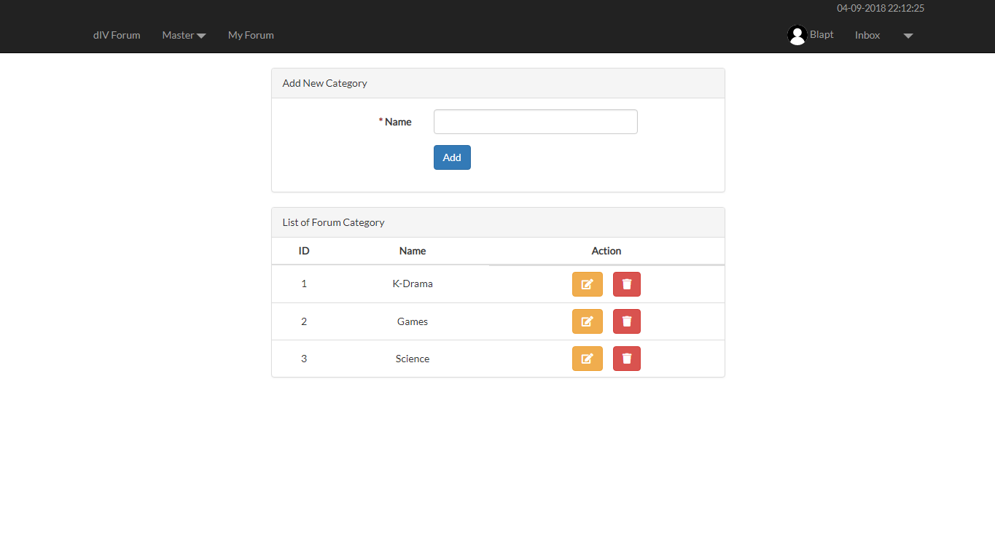

Figure 21. Master Category Page

1. Edit Category Page

This page allows user to **update** **category** **name**. The **name field** must be **filled** before user click **Update button**. If the user clicks **Update button**, then **update** **category**.

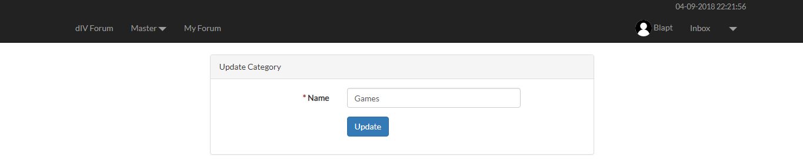

**Figure 22. Edit Category Page**

Here are the rules that you must follow to create your project:

1. Use appropriate software for this subject based on **Sistem Praktikum** that can be downloaded from Binusmaya.
2. Collect appropriate files for this subject based on **Sistem Praktikum** that can be downloaded from Binusmaya.
3. Include the other files that can support your project, such as:
   * All files in your project
   * Other files (image, audio, video, etc.) used in your project
   * *.DOC file (documentation of your project) that contains all pages in your project, reference links of additional files (image, audio, video, etc.) used in your project, the description about how to use your application, etc.
4. If there are some hidden creativities, please note them in the existing documentation because they can greatly affect your project score

**Reference**:

https://pbs.twimg.com/media/DUwdL8VVQAAUnjH.jpg

http://www.stickpng.com/img/icons-logos-emojis/users/simple-user-icon